|  |
| --- |
| Roomers Application |
| Project Deliverable 2- Sprint One’s Backlog |
| A step-by-step breakdown of requirements to be delivered in the first sprint. |

## **Submitted By:**

## Fizza Khalid – I212388

## Fatima Abid – I181597

## Maryam Zaheer -I180723

Table of Contents

Overview 1

Sprint Backlog 1

Screenshots of Trello Board 5

# Overview

This document shows a disintegration of the first sprint of our project Roomers where all the user stories are further broken down into sub stories and tasks and assigned to all the team members so the work can be completed in the estimated time frame.

# Sprint Backlog

Our work week will be from Monday-Friday and a work day will be of 8 hours.

## Module Name – Designing the Application’s Interface

|  |  |  |  |  |  |  |
| --- | --- | --- | --- | --- | --- | --- |
|  | Days left in Sprint | 15 days | 12 days | 9 days | 6 days | 3 days |
| Assignee | **Date** | 4/09/21 | 07/10/21 | 12/09/21 | 15/09/21 | 20/09/21 |
|  | **Total Estimated hours** | 120 hours | 96 hours | 72 hours | 48 hours | 24 hours |
|  | **User Story # 1 -** Creating the application’s main interface | 28 hours |  |  |  |  |
|  | **Description** - As a user, I want to have a user-friendly interface for Roomers application so that I can book a room as per my requirements. |
|  | **Sub user story** - The interface of the application should be interactive so the users find it intriguing to use the application for reservation purposes. |  |
| Fizza Khalid | **Tasks**  1. Research and analysis for the main layout. | 4 hours |
| Fizza Khalid | 2. Creating a prototype for clarifying ambiguities. | 8 hours |
| Fatima Abid | 3. Designing the main page layout using consistent UI elements to create an interactive interface. | 8 hours |
| Maryam Zaheer | 4. Peer review – code review done by a peer as per the initial requirements. | 4 hours |
| Maryam Zaheer | 5. QA verification – UI consistency. | 4 hours |
|  | **User Story # 2 -** Analyzing & Designing the Database |  |  |  |  |  |
| **Description** - As a user, I want to have tables in the database so that I can save all the relevant data. |
|  | **Sub user story** – Sketching up the database tables by defining their relationships with each other and sorting all the columns of each table. |  |  |  |  |  |
| Fatima Abid | **Tasks**   1. Analysis of the requirements and associated data | 8 hours |  |  |  |  |
|  | **User story# 3 -** Creation of database |  |  |  |  |  |
| **Description** - As a user, I want to create a database for storing all the information so that my application can be used easily once the data is processed. |
| Fatima Abid | **Tasks**   1. Create tables | 4 hours |  |  |  |  |
| Fatima Abid | 1. Identifying the primary and foreign keys for each table. | 1 hour |
| Fatima Abid | 1. Refine the design and apply normalization rules | 4 hours |
| Maryam Zaheer | 1. Peer review | 3 hours |
|  | **User story # 4 -** Establishing database connectivity with the GUI. |  |  |  |  |  |
| **Description** - As a user, I want to establish a connection of my DB with my app’s interface so that the application can be functional. |
| Fizza Khalid | **Tasks**  Creation of data access layer and connect DB using SQL connections. | 8 hours |  |  |  |  |
| Fizza Khalid | Creation of service layer for writing business logic for syncing data and UI. | 4 hours |
| Maryam Zaheer | Peer review. | 4 hours |
|  | **User story # 5 -** Registration process of an admin user |  |  |  |  |  |
| **Description** – As a user, I want a process to register an admin user so that an administrator can use the application. |
|  | **Sub user story-** A super admin will be able to login to the app for the first time and create a new user. Basic details like name and contact information will be taken from the super admin for creating a new user. Once the user role is selected, access rights as per the role will be applied for the newly created user. |  |  |  |  |  |
| Maryam Zaheer | **Tasks**   1. Design layout | 8 hours |  |  |  |  |
| Fizza Khalid | 1. Create business logic for adding and updating user | 5 hours |
| Fizza Khalid | 1. Bind list of active users from database with layout | 3 hours |
| Fatima Abid | 1. Peer review | 4 hours |
| Maryam Zaheer | 1. QA test cases | 4 hours |
| Maryam Zaheer | 1. QA verification | 4 hours |
|  | **User story # 6 -** Signing process of an admin user |  |  |  |  |  |
| **Description** – As a user, I want a login area from where a user can login to his/her account. |
|  | **Sub user story** - This user can be an admin, super-admin, customer or a receptionist. As per their user role, they will be able to perform different functionalities. For example, a customer will be able to view rooms and associated services with it. But they will not be able to create a new user in the system. |  |  |  |  |  |
| Maryam Zaheer | **Tasks**   1. Design layout | 4 hours |  |  |  |  |
| Fatima Abid | 1. Create business logic for user authentication | 4 hours |
| Fizza Khalid | 1. Validate User | 4 hours |
| Fizza Khalid | 1. Code review | 8 hours |
| Fatima Abid | 1. QA verification | 8 hours |

# Screenshots of Trello Board

1. Below image shows the start of the project when all the items are added to the ‘To Do’ list before the start of the sprint.

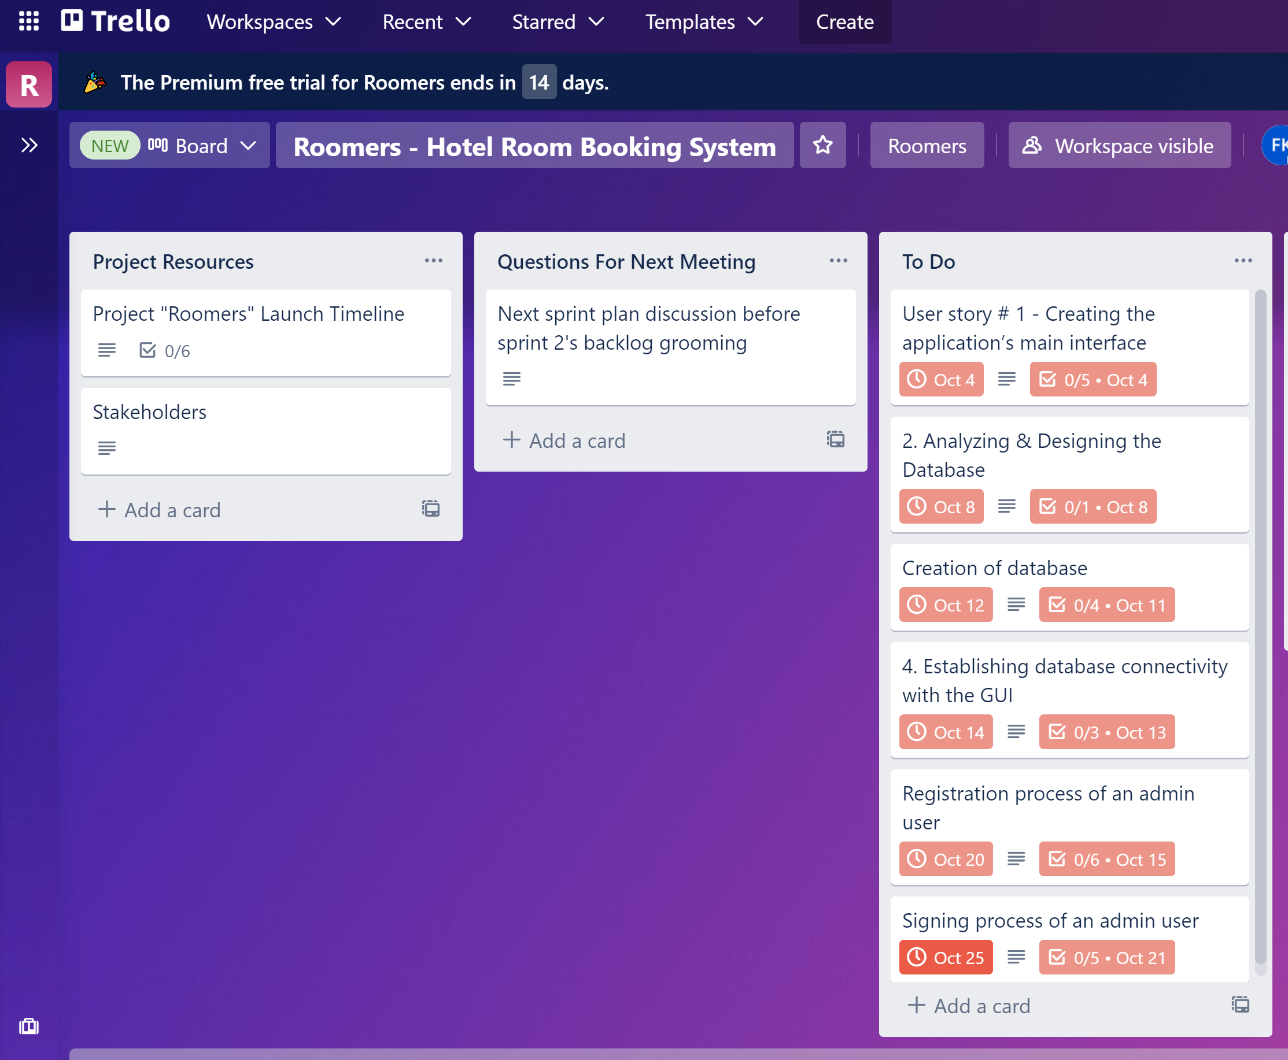

1. Second image displays the detail view of a user story:

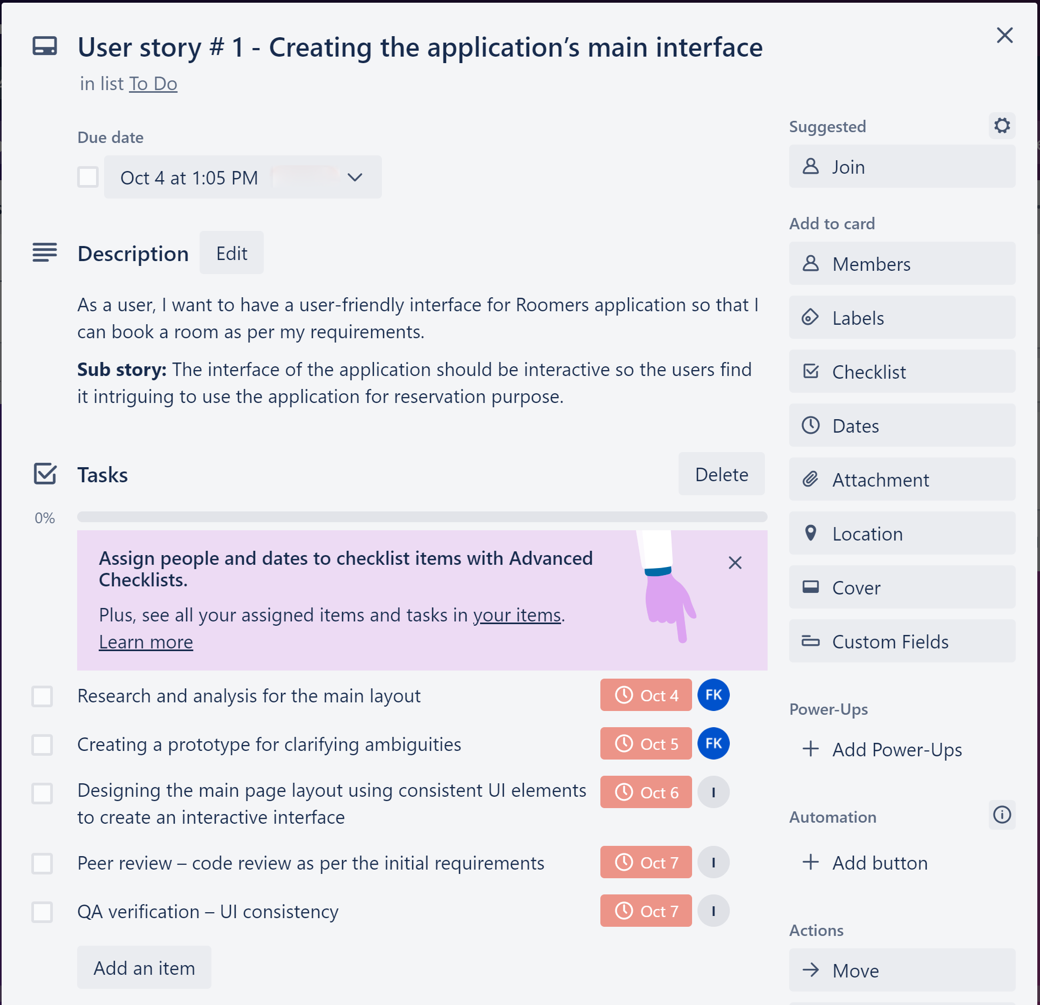

1. Image # 3 shows the progress of sprint 1.

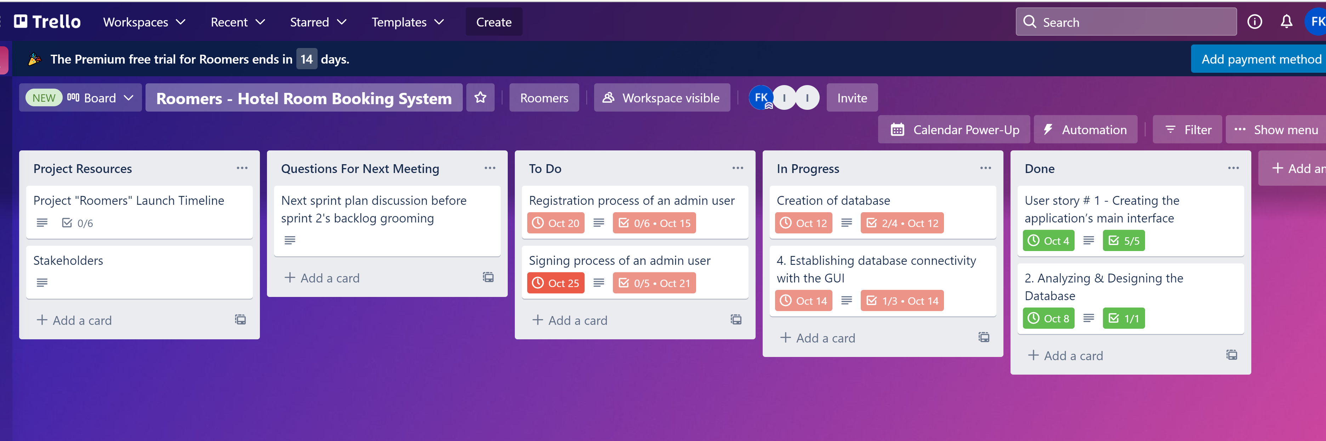

1. Image # 4 is the end of sprint 1 when all the items are completed.

